# This file is purely a demonstration of how I structured my Advice and Extra Content files. You won’t learn much from this and don’t bother trying. Everyone makes different mistakes when practising past papers. You should practise past papers yourself and try to come up with a similar file yourself. It’s the process of making the file that’s important, not the file itself.

# General Advice

* Add units to your final answers (eg, metres for vectors questions).
* “Fully justify to your answer” would mean go ahead and whip out the definition (like for bipartite).
* More often, try and show things are the case with maths rather than words (eg, matrix addition).

# Discrete

## DA - Graphs

* Pay careful attention to keywords and their definitions (eg, a simple graph doesn’t necessarily have to be connected).
* For a graph to have the same number of edges in a Hamiltonian cycle as the number of edges in an Eulerian trail, it must be 3 edges.
  + Since the number of edges in a Hamiltonian cycle equals the number of vertices and the number of edges in an Eulerian trail is n(n - 1)/2. Both these sequences have 3 in them.
* Remember to include the infinite face.

### Planar and non-Planar Graphs by Euler’s Formula

* You can use 2E ≥ 3F alongside Euler’s formula to show a graph is nonplanar.
  + This comes from the fact that all faces are made up of 3 edges and when counting all the faces, each edge is counted at most twice (as an edge sits in at most 2 faces.)
  + An example is shown below:

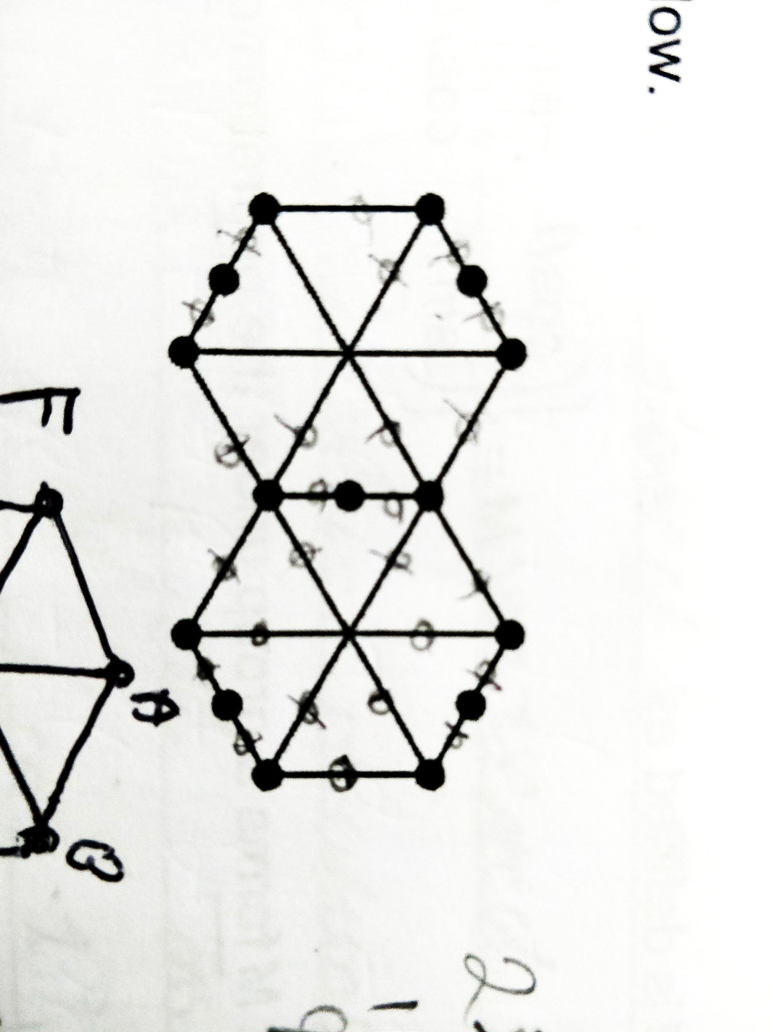

1. Let’s assume that the graph is planer so by Euler’s Formula: V + F - E = 2.
2. The graph has 15 vertices and 22 edges so must have 9 faces.
3. The shortest cycle in the graph has 5 edges so each face must have at least 5 edges. And each edge forms a boundary between 2 adjacent faces so 2E ≥ 5F.
4. However, 2E = 44 and 5F = 45 which is a contradiction thus N must be nonplanar.

* Don’t sweat it if you’re off by 1 or 2 for the shortest route in Chinese Postman, they usually accept at least 4 of the 6 correct. As long as you get the same answer.

*The below isn’t required but it is interesting.*

### Pigeonhole Principle

* If you must store n pigeons in k pigeonholes where n > k then at least 1 pigeonhole contains more than 1 pigeon.
* For handshakes, you can have: 0, 1, 2, 3, …, n - 1. Yet, if someone shakes no hands, no one can shake n - 1 hands and if someone shakes all hands, no one can shake 0 hands. Thus we have n people with n - 1 choices thus 2 people will shake the same number of hands.

## DB - Networks

* When making an edge mandatory in a MST, add the edge, and remove the largest arc that forms a cycle.
* Be sure to expand any shortened path someone takes (remember, they’re using indirect roots).

## DC - Network flows

* State “by the maximum-flow minimum-cut theorem” when using it. Especially for “fully justify your answer”.

## DD - Linear programming

* Under Simplex, state that you stopped because “the objective row is entirely non-negative.”
* Remember to…
  + Declare the lower limits (e.g., x, y, z ≥ 0) if undefined.
  + Label the feasible region.
  + Use simultaneous equations to work out the exact amount.
  + Write “the number of … produced.”
* If it asks to “work out the profit” then take into account cost.
* A linear programming problem requiring integer solutions may require comparing the local integer coordinates to an optimal vertex.
* Double check your simplex tableau with the constraints.

### Objective Line

P = 3x + y ⇒ y = -3x + P

* And thus draw a gradient of -3 using the change in height and width idea.

## DE - Critical path analysis

* Ensure you perform the backwards pass properly - minus the duration from the late time ∵ if you think about it, it’s the latest an activity can start without delaying the project.
* When drawing cascade diagrams, ensure there’s no gaps along the y-axis to ensure all the workers have been used.
* Add a start and an end to the activity network. You gotta make sure the final activites end at the same time.
* Consider carefully the effect on all activities in the critical path.

## DF - Game theory for zero-sum games

* Remember that you will have to keep switching perspectives.
* The point of intersection is the maximum point where an outcome is **GUARANTEED**.
* When concluding an optimal mixed strategy, mention which strategies and with what probabilites.
* Show that the game requires an optimal mixed strategy by showing there is no stable solution.
* The assumption made when a player uses an optimal mixed strategy is that the other does too.
* Always check for dominance and mention it at the beginning of any problem (where there is or isn’t any).

## DG - Binary operations and group theory

* You cannot have two identity elements (e.g., one for a * b and another for b * a).
  + This is because… Suppose e and f are both identity elements then e * f = e where e is the identity element and e * f = f where f is the identity element. Thus e = f.
* Remember the mudolo symbol can be written as 7 +8 5 = 4 and 7 x4 5 = 3.
* Use Cayley Tables a lot more often, they can be very useful. Especially for finding inverses:

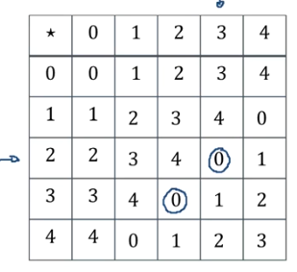

* Be sure to write a conclusion about it being a group.
* Subgroup must also fit al the conditions for a group.
* If every row and every column has an identity element it means each element has an inverse.
* Every row and every column must contain all group elements and no duplicates (this can be proved easily).

# Statistics

* You can use conditional probability here too, remember that!
* Be specific and state the population when you can (ie, level of purity and mass of crisps).
* State the mean for a Poisson Distribution because why not.
* “Fail to reject H0”.

## SA - DRVs and expectation

* Use the fact that for the mean and variance of uniform distribution (1, 2, 3, ...) can related by a linear relationship.
* Write the formula for expected value to ensure you work it out correctly.

## SB & SC - Poisson distribution & type I/II errors

* You cannot conclude a test with certainty, “some certainty” is better.
* Keep in mind that the hypotheses should be made about parameters (for chi-squared tests, it’s a statement).
* For a Type I error, you won’t get exactly 5% as Poisson is discrete, look for the p-value of the critical value (perhaps 4.6%).
* Careful with parameters lambda and mu, use lambda for tests with Poisson.
* No queues in Poisson (eg, on the motorway) for independent.

## SD - CRVs

* For working out cumulative distribution functions by integration, use + a, + b, + c after each integrated part and equate this from the start to find all of them. Be careful of gaps.

## SE - Chi tests for association

* Use fractions more often in this so you won’t have to type in as many numbers. Don’t round since rounding each value can drastically affect your answer.
* Make a plausible observation for any association (if there aren’t any, state the observed and expected frequencies are sufficiently close).
* The assumption made about the sample data for a chi-squared test to be valid is that a random sample is used.

## SF - Exponential distribution

* Try and spot λe-λx.
* Exponential models waiting time between Poisson events whereas Poisson is the number of exponential events in unit time. Lambda = 1 / (waiting time between poisson events).

## SG & SH - t-distribution & confidence intervals

* Recognise when a t-test is being used and use inverse t, if necessary.
* Recognise when a t-test is being used. Use inverse t-distribution from the tables.
* A larger sample means a sample variance closer to the population variance.
* When it says to “fully justify your answer” then say a t-test / t-distribution was used as the n < 30 **and** population variance is unknown.
* Always check the tables for the t-values, don’t end up using a z-distribution.

use constructed and/or given confidence intervals, identifying that:

• if a confidence interval contains a given value then there is insufficient evidence that the

population mean differs from this value

• if a confidence interval is completely below a given value then there is significant evidence the

population mean is less than the given value

• if a confidence interval is completely above a given value then there is significant evidence the

population mean is greater than the given value

• if the confidence intervals overlap then there is insufficient evidence of a difference between

the population means from which the samples were taken

• if the confidence intervals do not overlap and the confidence interval for μA is below the

confidence interval for μB then there is significant evidence of a difference between the

population means from which the samples were taken and that μB > μA